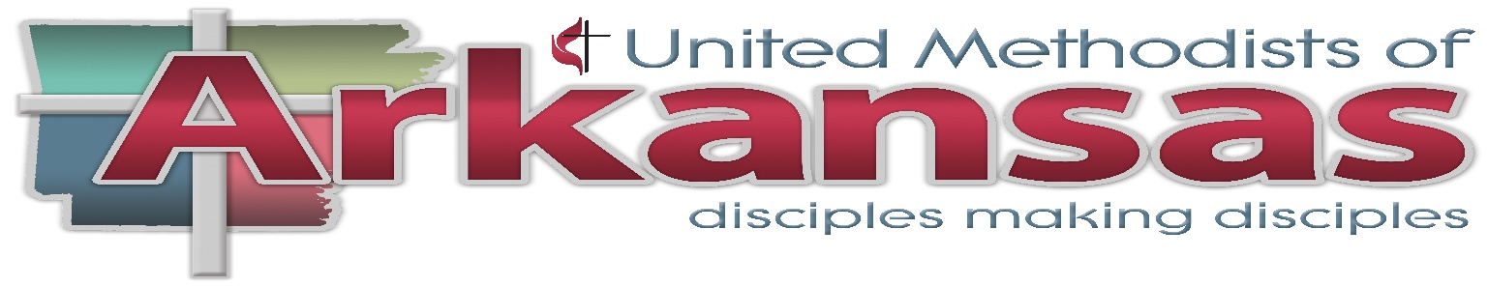
Arkansas Conference Ethnic and Language Concerns Committee Ministry Grant Application: 2018
Mission Field Deadline – On-going

Applicant Name (church or individual): _

Local Church: _ District:_

Mailing Address (where check is to be sent):_

City State ZIP
Contact Number: [ ] Business [ ] Cell [ ] Home

Email (required): _ Ethnicity:

Printed Name and Signature of person/s submitting grant application:

(print) _ (signature)
Signature of Pastor: _ _ _

What is the Purpose of the Arkansas Conference Committee on Ethnic and Language Concerns?
The Committee on Ethnic and language Concerns shall collaborate with the existing structures of the annual Conference in order to implement, evaluate, and update the annual Conference of its comprehensive plan as it relates to ethnic issues. The Committee will consult with and assist other conference entities in training and implementation of matters related to ethnic local churches. The committee shall maintain the connectional relations mandated by ¶632 and ¶ 654. Additionally, this committee shall be charged with implementing all General Conference emphases related to:
- National Hispanic Plan
- Strengthening the Black Church for the 21st Century
- National Korean Ministry Plan
- Native American Ministries (¶654)
- Other ethnic programs emanating from the General Conference.

How do these grants fit into the Bishop’s Mission Plan?
All Mission Field Grants must provide for at least three (3) of these specific components of the Bishop’s Mission Plan [Note: #4 has been omitted on purpose]:
- How will this grant assist this congregation in spiritual revival?
- How will this grant assist this congregation in “Fruit-bearing’?
- How will this grant assist this congregation in aligning with its District Mission Plan?
- How will this grant assist this congregation in looking more like their neighbors?
- How will this grant assist this congregation in growing by professions of faith, worship, or small group ministries that target the mission field?
- How will this grant empower laity?
- How will this grant empower clergy?
- How will this grant assist in creating vital, self-sustaining and growing African-American churches?
- How will this grant assist this congregation in connecting with the previously churched, de-churched and never churched, or the “nones”?

Please provide the following information for your grant application. For your convenience you enter all information on this form. Please provide all items requested/required.

A Mission Field Ministry Grant (programmatic): Assists congregations in enhancing outreach ministries to community (Mission Field) as related to these Arkansas Conference Priorities.
- Youth and Young Adults
- Developing new ministries for your mission field
- Provides matching support for an existing ministry expansion

Mission Field Grants please answer the following five (5) questions and complete checklist. You may answer in space provided and by attaching another document to your request.

- Name of Project: _

- Start date End date ___________________

- This project address these three goals contained within the Bishop’s Mission Plan:

a. _ _ _

b. _ _ _

c. _ _ _

- This grant will make disciples for Jesus Christ because

_ _ _

_ _ _

_ _ _
- We plan for this project to continue after the funding from Ethnic and Language Ministries expires as a result of _ _ _
_ _ _ _

_ _ _ _

Mission Field Grant Project Checklist:

[ ] The project budget is attached that demonstrates: [ ] a. Funding from my local church
[ ] b. Funding from my district (optional)
[ ] c. In-kind donations (optional) ex: food donated by Sunday School group
[ ] d. Amount of my request from the Ethnic and Language Committee (cannot exceed other grant components combined)

Elder Ronnie Miller-Yow is the chairperson of the Ethnic and Language Committee. The Committee makes all decisions regarding grants. Committee members are:

Central District – Dr. Zenobia Harris, zharris@prodigy.net, 501.680.3072
Northeast District – Rev. Herschel Richardson, herschelrichardson@sbcglobal.net
870.219.2340
Northwest District – Rev. Kwangmin Shin, my1000uk@gmail.com, 479.263.5434 Southeast District – Mrs. Helen Emerson, helenemerson@sbcglobal.net, 870.534.6900 Southwest District – Rev. Tommy Halsell, tommyhalsell@yahoo.com, 870.584.2454

Arkansas Conference Ethnic and Language Conference
Mission Field Grant Evaluation

Note: completed form must be submitted to Committee Chairperson within 30 days of receipt or of the event funded whichever comes latest. Please only provide information requested.

No additional funding will be considered without receipt of this evaluation.

Applicant Name (church or individual): _

Project Name (for Mission Field Projects): _

Local Church: _ District:_

Mailing Address (where check is to be sent):_ _ _

_ _ _ City State ZIP

Contact Number: _ _ _ [ ] Business [ ] Cell [ ] Home

Email (required): _ _ Ethnicity:

For funding:

- Was the support received from the Committee on Ethnic and Language Concerns satisfactory in fulfilling your funding needs? Why or Why not? (attach statement)

- Attach SUMMARY of participant evaluations (1-2 pages)

